Lipids and fats
Lipids are a broad group of naturally-occurring molecules which includes fats, waxes, sterols, fat-soluble vitamins (such as vitamins A, D, E and K), monoglycerides, diglycerides, phospholipids, and others.
Chemically, fats are generally triesters of glycerol and fatty acids. Although the term lipid is sometimes used as a synonym for fats, fats are a subgroup of lipids called triglycerides. Structural variation within each class is due to the different fatty acid residues that may be present. Triglycerides are 'simple' if the same fatty acid is present in all three positions in the molecule. Much more common are 'mixed' triglycerides, in which different fatty acids are present in all three positions.
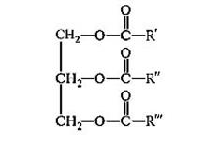
A general formula of fats (R’, R’’, R’’’ – fatty acids)

A fat's constituent fatty acids may also differ in the number of hydrogen atoms that are bonded to the chain of carbon atoms. Each carbon atom is typically bonded to two hydrogen atoms. When a fatty acid has this typical arrangement, it is called "saturated", because the carbon atoms are saturated with hydrogen; meaning they are bonded to as many hydrogens as possible. In other fats, a carbon atom may instead bond to only one other hydrogen atom, and have a double bond to a neighboring carbon atom. This results in an "unsaturated" fatty acid. More specifically, it would be a "monounsaturated" fatty acid (one double bond), whereas, a "polyunsaturated" fatty acid would be a fatty acid with more than one double bond.
Glycerophospholipids, also referred to as phospholipids, are ubiquitous in nature and are key components of the lipid bilayer of cells, as well as being involved in metabolism and cell signaling. By contrast with the numerous types of phospholipids in plants, there are only a few glycolipids.
Chemically, a wax is a type of lipid that may contain a wide variety of long-chain alkanes, esters, polyesters and hydroxy esters of long-chain primary alcohols and fatty acids. They are usually distinguished from fats by the lack of triglyceride esters of glycerin (propan-1,2,3-triol) and three fatty acids. Animal waxes are exemplified by Beeswax (produced by honey bees), Lanolin (from the sebaceous glands of sheep), Spermaceti (from the head cavities and blubber of the sperm whale); and vegetable ones – by Carnauba wax (from the leaves of the Carnauba palm, Copernica cerifera), Jojoba oil (as a replacement for spermaceti, jojoba is pressed from the seeds of the jojoba bush, Simmondsia chinensis).

MPM name | Source | Constituents | Action, use
Oleum Amygdalarum | Amygdalus communis L. var. dulcis Borkh ex DC.,or Amygdaluscommunis L. var. amaraLudwig ex DC.,Rosaceae. | Bitter almond: Fatty oil (non-dehydrating): chief fatty acids oleic acid and linoleic acid; Cyanogenic glycoside amygdalin; Arabinogalactans; Proteic substances.  Sweet almond: Fatty oil: chief fatty acids oleic acid and linoleic acid.Arabinogalactans. Proteic substances | Sweet Almonds have a demulcent and a mild laxative effect. Sweet Almonds are used topically in skin care and liniments. The volatile almond oils are used as flavouring agents.
Oleum Persicorum | Persica vulgaris Mill. or ArmeniacavulgarisLam., Rosaceae | Peach oil yield triglyceride of oleinic acid and glycerides of linoleic acid. Seeds contain cyanogenetic glycosides, including amygdalin. | Emollient; as a substitute for expressed oil of almond in cold cream and other preparations whose formulas contain expressed oil of almond.Seeds of Prunus persica are used in Chinese medicine due to circulatory stimulant, aperient and antitussive activities.
Oleum Arachidis | Arachis hypogaea L., Fabaceae. | Fatty oil: chief fatty acids include oleic acid, linolic acid and palmitin acid. Also present in small quantities are longer chained fatty acids such as eicosanoic acid and tetracosanoic acid. | as a vehicle for medication in external, enteral or parenteral preparations; the cosmetics industry uses it in skin, sun and massage oil. It is used as a salad or cooking oil that is said to lower blood cholesterol levels.
Oleum Ricini | Ricinus communis L.,Euphorbiaceae | Castor oil seeds: Fatty oil; Proteic substances; Lectins; Pyrridine alkaloid ricinine. Triglycerides: chief fatty acid is ricinoleic acid. Tocopherols (vitamin E).  The fixed oil consists of the glycosides of ricinoleic, isoricinoleic, stearic and dihydroxystearic acids. | Stimulant laxative; emollient. Castor-oil seeds are employed mainly for the preparation of castor oil which is extensively used as a purgative and lubricant.
Oleum Cacao (Butyrum Cacao) | Theobroma cacao L., Sterculiaceae | Cocoa butter: Triglycerides: chief fatty acids oleic acid, stearic acid, palmitic acid. Free fatty acids. Steroids: sterols, including β-sitosterol. Purine alkaloids | in the making of suppositories (suppository basis), as an excipient for certain pills, and as an emollient; as an inactive ingredient in dermatologic preparations.
Oleum Olivarum | Olea europaeaL., Oleaceae | chief fatty acids are oleic acid, palmitic acid, linoleic acid. Steroids: β-sitosterol, stigmasterol. Tocopherols. | as a lubricant for constipation and dry skin conditions; in the preparation of parenteral drugs, etc., as a salad oil;  has an antisclerotic effect;
Helianthi annui oleum raffinatum | Helianthus annuus L., Asteraceae | Triglycerides: chief fatty acids are linoleic acid, oleic acid, palmitic acid. Sterols campesterol, cholesterol, β-sitosterol | internally to alleviate constipation (as a lubricant); externally as massage oil, for poorly healing wounds (as an oil dressing) and in the treatment of skin lesions, psoriasis and rheumatism.
Cera (beeswax) | purified honeycomb of Apis mellifica and other bees, Apidae | a wax, consisting of about 80% of myricyl palmitate (myricin), with possibly a little myricyl stearate; free cerotic acid, cerolein, hydrocarbons, cholesteryl esters. | yellow wax is used in the preparation of ointments, polishes and plasters
Adeps lanae (Lanolinum) | purified fat – like substance prepared from the wool of the sheep Ovis aries, Bovidae | cholesterol and isocholesterol (monohydric alcohols) in combination with lanoceric, lanopalmitic and other fatty acids. Wool fat also contains aliphatic alcohols such as cetyl, ceryl and carnaubyl alcohols | wool fat is used as an emmolient base for creams and ointments
Cetaceum | waxy substance obtained from the head of the sperm whalePhyseter macrocephalus, Physeterides | cetyl palmitate or cetin and small percentages of other fatty substances | as a base for cerates and ointments. Sperm oil is widely used as a lubricant for machinery, especially sewing machines

Amygdalus communis

Botanical Origin.—Amygdalus communis L. var. dulcis Borkh ex DC. ((Prunus amygdalus (L.) Batsch var. dulcis) (Borkh ex DC.) Koehne) (Engl. — Sweet Almond, Jordan-, Valencia-, or Malaga Almonds, Greek Nuts; Ukr. — Мигдаль солодкий; Rus.— Миндаль сладкий), Amygdalus communis L. var. amara Ludwig ex DC. ((Prunusamygdalus (L.) Batsch var. amara) (Ludwig ex DC.) Focke) (Engl. — Bitter Almond; Ukr. — Мигдаль гіркий; Rus. — Миндаль горький). Family – Rosaceae.
Part Used.—Oleum Amygdalarum consists of the fixed oil, obtained by expression from the seeds of Amygdalus communis L. var. dulcis Borkh ex DC., orAmygdalus communis L. var. amara Ludwig ex DC., Rosaceae.
Habitat.—The tree is indigenous to Western Asia (Asia Minor) and is extensively cultivated in many regions. The oil is mainly produced from almonds grown in the countries bordering the Mediterranean.
Plant.—The plant is of medium height, seldom reaching 12 m. It is a tree or shrub with mildly red - tinged branches, thorny in its wild form but not in the cultivated form. The leaves have a 1.2 to 1.5 cm long, glandular petiole and glabrous, oblong – lanceolate - acuminate or serrate, tough, glossy, dark green blades. The flowers are very short - petioled in pairs and appear before the leaves. The petals are 19 to 20 mm long, pale pink to whitish with dark veins. The fruit is oblong-ovoid, compressed. 3.5 to 4.6 cm long by 2.5 to 3 cm wide, gray-green, velvet-downy and pubescent. The nut shell is yellow, hard, compressed, broad- and sharp-edged, punctuate externally with irregular grooves, smooth and glossy inside and thick- or thin-skinned. The seed is cinnamon brown, flattened, and 2 cm long by 1.2 to 1.5 cm wide. When ripe the portion of the pericarp external to the endocarp splits into two halves and falls off the stone or "shell."
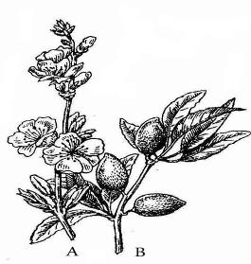

Fig. Amygdalus communis. A – Branch, bearing leaves and flowers;
B - Branch, bearing fruit
MPM Description.—The seeds are entire, ovate or oblong-lanceolate, exalbuminous, up to 30 mm. in length, up to 17 mm in breadth and 9 mm or less in thickness; spermoderm thin, yellowish- to reddish-brown, coarsely longitudinally furrowed, easily removed on soaking the seed in water; embryo straight, whitish, consisting of two large plano-convex cotyledons, a short conical hypocotyl, and a short plumule at the pointed end of the seed; odour slight; taste bland and sweet. Upon bruising and triturating in water, a milk-white emulsion is produced which is devoid of the odour of benzaldehyde or hydrocyanic acid.
Expressed Almond Oil (Oleum Amygdalae expressum), or Sweet Almond Oil is a fixed oil obtained from the kernels of varieties of Prunus amygdalus (L.) Batsch. It is a clear, pale straw coloured or colourless oily liquid with a bland taste; sp. gr. 0.910 to 0.915 at 25°C.
According to the EP., Refined almond oil is the fatty oil from the ripe seeds ofPrunus dulcis (Miller) D.A. Webb var. dulcis or Prunus dulcis (Miller) D.A. Webb var. amara (D.C.) Buchheim or a mixture of both varieties by cold expression. It is then refined. A suitable antioxidant may be added.
Refined almond oil is a pale yellow, clear liquid, slightly soluble in alcohol, miscible with light petroleum. It solidifies at about - 18 °C and has a relative density of about 0.916. Acid value: not more than 0.5, determined on 5.0 g. Peroxide value: not more than 5.0. Unsaponifiable matter: not more than 0.7 per cent, determined on 5.0 g.
According to the EP., Virgin almond oil is a fatty oil obtained by cold expression from the ripe
seeds of Prunus dulcis (Miller) D.A. Webb var. dulcis or Prunus dulcis (Miller) D.A. Webb var.
amara (D.C.) Buchheim or a mixture of both varieties.
Virgin almond oil is a yellow, clear liquid; slightly soluble in ethanol (96 per cent), miscible with
light petroleum. It solidifies at about − 18 °C and its relative density is about 0.916. Acid value:
maximum 2.0, determined on 5.0 g. Peroxide value: maximum 15.0. Unsaponifiable matter: maximum
0.9 per cent, determined on 5.0 g.
Constituents.—Bitter almond: Fatty oil (non-dehydrating, 38 to 60%): chief fatty acids oleic
acid (77%) and linoleic acid (17 to 20%). Cyanogenic glycosides: amygdalin, 0.2 to 8.5%
(corresponding to 12 to 500 mg prussic acid per 100 gm). Mucilages (3 to 3%):
arabinogalactans. Proteic substances (25 to 35%).
Sweet almond: Fatty oil (non-dehydrating, 43 to 57%): chief fatty acids oleic acid (77%) and
linoleic acid (17 to 20%). Mucilages (3 to 4%): arabinogalactans. Proteic substances (20 to 25%).
Pharmacological Action. Uses.—Sweet Almonds have a demulcent and a mild laxative effect.
Sweet Almonds are used topically in skin care and liniments. The volatile almond oils are used as
flavouring agents.

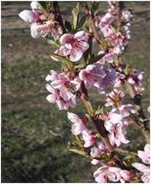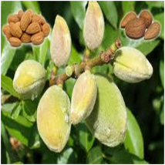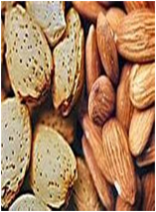

Persica vulgaris

Botanical Origin.—Persica vulgaris Mill. (Prunus persica (L.) Batsch). (Engl. — Peach, Nectarine; Ukr. — Персик звичайний; Rus. — Персик обыкновенный), Armeniaca vulgaris Lam. (Prunus armeniaca L.) (Engl. — Apricot Tree, Chinese Bitter Almond; Ukr. — Абрикос звичайний; Rus. — Абрикос обыкновенный). Family – Rosaceae.
Part Used.—Oleum Persicorum consist of the fixed oil, expressed from the kernels of varieties of Persica vulgaris Mill. or Armeniaca vulgaris Lam., Rosaceae.
Habitat.—Asia. The peach tree is a native of China. The apricot tree, probably from Siberia to China.
Plant.—Peach is of 3-5 m height. It is a tree or shrub. The leaves lanceolate, serrate, petioles short. The flowers are pale pink. The fruit is a drupe.
MPM Description.—A clear, pale straw-coloured or colourless, oily liquid, almost odourless and with a bland taste; sp. gr. 0.910 to 0.918 at 25° C.

Constituents.—Peach oil yield triglyceride of oleinic acid and glycerides of linoleic acid. Seeds contain cyanogenetic glycosides, including amygdalin.
Pharmacological Action. Uses.—Emollient; as a substitute for expressed oil of almond in cold cream and other preparations whose formulas contain expressed oil of almond.Seeds of Prunus persica are used in Chinese medicine due to circulatory stimulant, aperient and antitussive activities
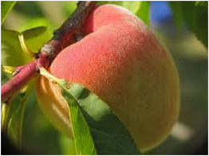

Arachis hypogaea

Botanical Origin.—Arachis hypogaea L. (Engl. — Arachis, Ground-nut, Peanut; Ukr. — Арахіс підземний; Rus. — Арахис подземный). Family – Fabaceae.
Part Used.— Oleum Arachidis consists of the fixed oil, obtained by cold pressure from the peeled seeds of Arachis hypogaea L., Fabaceae.
Habitat.—Peanuts were originally indigenous to tropical and sub-tropical South America. Today, Arachis hypogaea is cultivated in all tropical and sub-tropical regions worldwide except in the rain forests.
Plant.—The peanut plant is an annual herbaceous 30 to 70 cm high legume, with glabrous, double pinnate leaves and with thick, angular, pubescent, branching stems which are prostrate in the running varieties or upright in the bushy varieties. Leaves paripinnate and usually with 2 pairs of subsessile, entire leaflets and elongated stipules. The flowers are 5 to 7 cm long, monosymmetrical and have a large golden-yellow standard. The flowers have lemon-yellow wings and a pure white carina. They are arranged singularly or in pairs in the leaf axils. They blossom at sunrise and wilt in the same morning, during which time they stretch from 5 to 20 cm and act negatively phototropically downward. After pollination, a meristem develops at the base of the ovary, from which the fruit axis grows. The fruit only starts to grow when the stem is 5 to 10 cm underground, where it grows horizontally. The fruit is a 4 cm long by 1.5 cm thick closed pod with a fibrous, reticulate-wrinkled wall and 1 to 4 large seeds with no endosperm and a thin, red shell.

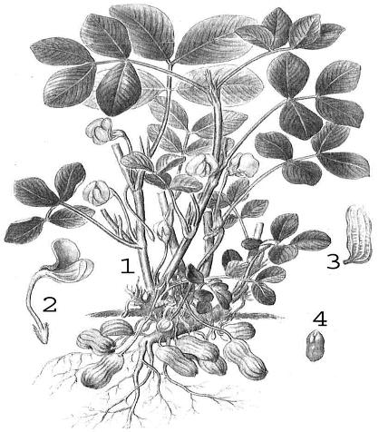
MPM Description.—According to the EP., Refined Arachis Oil is obtained from the shelled seeds of Arachis hypogaea L. A suitable antioxidant may be added.
Refined Arachis Oil is a clear, yellowish, viscous liquid. Very slightly soluble in alcohol, miscible with light petroleum. Relative density: about 0.915. It solidifies at about 2 °C. Acid value: maximum 0.5, determined on 10.0 g. Peroxide value: maximum 5.0. Unsaponifiable matter: maximum 1.0 per cent, determined on 5.0 g.
According to the EP., Hydrogenated arachis oil is the product obtained by refining, bleaching, hydrogenating and deodorizing oil obtained from the shelled seeds ofArachis hypogaea L. Each type of hydrogenated arachis oil is characterized by its nominal drop point.
A white or faintly yellowish, soft mass which melts to a clear, pale yellow liquid when heated, practically insoluble in water, freely soluble in methylene chloride and in light petroleum (bp: 65 °C to 70 °C), very slightly soluble in alcohol.
Constituents.—Fatty oil: chief fatty acids include oleic acid, linolic acid and palmitin acid. Also present in small quantities are longer chained fatty acids such as eicosanoic acid and tetracosanoic acid.
Pharmacological Action. Uses.—Arachis oil has similar properties to olive oil, is used as a substitute for olive oil when the latter is not available. The pharmaceutical and medical industries use peanut oil as a vehicle for medication in external, enteral or parenteral preparations; the cosmetics industry uses it in skin, sun and massage oil. The effect obtained when used as an enema for constipation and in dermatology for dry skin, eczema and dandruff is achieved primarily from the drug's oiliness, although it has been shown to contain lectines. It is used as a salad or cooking oil that is said to lower blood cholesterol levels.
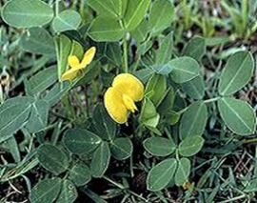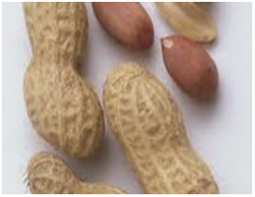

Ricinus communis

Botanical Origin.—Ricinus communis L. (Engl. — Castor Bean, Castor Oil Plant; Ukr. — Рицина звичайна; Rus. — Клещевина обыкновенная). Family –Euphorbiaceae.
Part Used.—Oleum Ricini consists of the fixed oil, obtained from the seeds ofRicinus communis L., Euphorbiaceae.
Habitat.—India. Widely naturalized and cultivated. The plant is cultivated widely today in the tropics and subtropics and in temperate latitudes where maize thrives. Castor-oil plant is either found under cultivation or growing wild in most tropical and warm temperate countries.
Plant.—Ricinus communis is an annual plant in Central Europe, a bi- or -triennial shrub in Southern Europe and a perennial tree in the tropics. There are hundreds of forms of the plant which vary in size, colour of stem and leaves, leaf markings, branching, size, color and markings of seeds, etc.
There is a taproot and lateral roots near the surface. The stem is erect and hollow. As it grows older, the stem becomes green or brownish-red. The leaves are petioled, greenish or reddish, often frosted blue, and arranged in a spiral. The leaf blade is peltate, 10 to 60 cm long and wide. The blade is usually divided into palmate, ovate-oblong or lanceolate lobes. The ribs are palmate and the margins are irregularly serrate. The inflorescences are terminal and almost panicled and 15 to 50 cm long. The pedicled female flowers are in the upper section and the male flowers are clustered in the lower section of the inflorescence. The male ones have a 3 to 5 part perianth with numerous, heavily branched stamens which bear up to 1,000 separate bursting anthers. The female perianth is divided in 5. The ovary is trilocular. The style has 3 red, doubly split stigma branches. The fruit a 3-celled capsule is soft prickly or smooth and grooved, 1 to 2.5 cm in diameter, dehiscing into 3 cocci, each containing an ovoid albuminous seed. The capsule bursts open when ripe flinging out the large brightly speckled seeds.

Fig. Ricinus communis

MPM Description.—Seed anatropous, albuminous, ovate-oblong, from 8 to 18 mm in length and up to about 8 mm in breadth, flattened on the ventral surface, the dorsal surface convex; at one end is a wart-like caruncle covering the micropyle from which a line-like raphe extends to the chalaza at the other end of the seed; testa smooth, glossy and brittle, grayish or gray-brown and marbled with reddish-brown to black spots and lines; tegmen white, membranous, adhering to the large, yellowish-white, oily endosperm which surrounds a straight embryo; embryo extending lengthwise between, the halves of endosperm and consisting of 2 papery cotyledons and a conical hypocotyl; nearly inodourous; taste oily and acrid. This seed should not be swallowed owing to its poisonous properties.
Castor Oil has a faint, mild odour and a bland afterwards slightly acrid and usually nauseating taste. It differs from most other fixed oils in being only partly soluble in petroleum benzine and in yielding a clear liquid with an equal volume of alcohol.
According to the EP., Virgin Castor Oil (Ricini oleum virginale) is a fatty oil obtained by cold expression from the seeds of Ricinus communis L. A suitable antioxidant may be added.
Virgin Castor Oil is a clear, almost colourless or slightly yellow, viscous, hygroscopic liquid. Slightly soluble in light petroleum, miscible with alcohol and with glacial acetic acid. Relative density: about 0.958. Refractive index: about 1.479. Optical rotation: + 3.5° to + 6.0°. Iodine value: 82 to 90. Acid value: maximum 2.0. Dissolve 5.0 g in 25 ml of the prescribed mixture of solvents. Hydroxyl value: minimum 150. Peroxide value: maximum 10.0. Unsaponifiable matter: maximum 0.8 per cent, determined on 5.0 g.
According to the EP., Refined Castor Oil (Ricini oleum raffinatum) is a fatty oil obtained from the seeds of Ricinus communis L. by cold expression. It is then refined. A suitable antioxidant may be added. During the expression step, the temperature of the oil must not exceed 50 °C.
Refined Castor Oil is a clear, almost colourless or slightly yellow, viscous, hygroscopic liquid; slightly soluble in light petroleum, miscible with ethanol (96 per cent) and with glacial acetic acid. Optical rotation: + 3.5° to + 6.0°. Acid value : maximum 0.8. Hydroxyl value: minimum 150. Peroxide value: maximum 5.0. Unsaponifiable matter: maximum 0.8 per cent, determined on 5.0 g.
According to the EP., Hydrogenated Castor Oil (Ricini oleum hydrogenatum) is a fatty oil obtained by hydrogenation of Virgin Castor oil. It consists mainly of the triglyceride of 12-hydroxystearic (12-hydroxyoctadecanoic) acid.
Hydrogenated Castor Oil is a fine, almost white or pale yellow powder or almost white or pale yellow masses or flakes; practically insoluble in water, slightly soluble in methylene chloride, very slightly soluble in anhydrous ethanol, practically insoluble in light petroleum. Melting point: 83 °C to 88 °C. Acid value: maximum 4.0, determined on 10.0 g dissolved in 75 ml of hot ethanol (96) per cent R. Hydroxyl value: 145 to 165, determined on a warm solution. Iodine value: maximum 5.0.
Constituents.—Castor oil seeds: Fatty oil (42 to 55%). Proteic substances (20 to 25%). Lectins (0.1 to 0.7%): including ricin D (RCA-60, severely toxic), RCA-120 (less toxic). Pyrridine alkaloids: ricinine (up to 0.3%). Triglycerides: chief fatty acid is ricinoleic acid (12-hydroxyoleic acid, 85 to 90%). Tocopherols (vitamin E).
The fixed oil consists of the glycosides of ricinoleic, isoricinoleic, stearic and dihydroxystearic acids.
Pharmacological Action. Uses.—Stimulant laxative; emollient. Castor-oil seeds are employed mainly for the preparation of castor oil which is extensively used as a purgative and lubricant. Free ricinolic acid is produced by hydrolysis of castor oil in the intestines; to it the purgative action of castor oil has been attributed. Ricinolic acid is anti-absorptive and secretogogic. Castor Oil is used internally in folk medicine for acute constipation, intestinal inflammation, for removal of worms. The EP comprises Zinc and Castor Oil Ointment. The oil is used externally for inflammatory skin disorders.
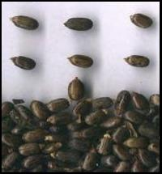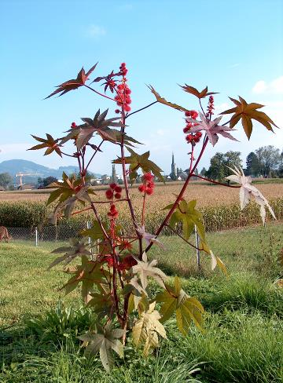

Theobroma cacao

Botanical Origin.—Theobroma cacao L. (Engl. — Cocoa Bean, Cocoa Seed; Ukr. — Шоколадне дерево; Rus. — Шоколадное дерево). Family – Sterculiaceae.
Part Used.—Oleum Cacao (Butyrum Cacao) is the hard fat obtained from the ripe cocoa seeds of Theobroma cacao L., Sterculiaceae.
Habitat.—South America, Central America, West Indies, and Mexico. The plant is cultivated globally in tropical regions.
Plant.—The plant is a 4 to 6 m occasionally up to 13 m, tall tree with an irregular knotty trunk and a broad crown. The young branches are rounded. The leaves are coriaceous or paper-like, alternate and in 2 rows on the branches. The petiole is downy, cushioned, and 1.5 to 2 cm long. The lamina is oval or elliptical, slightly asymmetrical, rounded at the base with a conspicuous tip. The upper surface is green and pale when dry. The lower surface is paler green, glabrous or has a few, tiny, simple, branched and scattered hairs. The inflorescences are on the main trunk and thicker branches on a so-called "flower cup". The cyme-like branchlets are short, noded and persistent. There are 5 sepals, which are narrow. The petals are cap-shaped and stemmed with flag-like laminas. The stamen tube, with 5 fertile stamens and 5 awl-shaped staminoids, is short. The fruit is a 15 to 25 cm long and 10 cm thick, large berry. It is oblong or obovate, thick-skinned, yellow or reddish, grooved and sometimes bumpy and cucumber-like. The 20 to 50 seeds are arranged in rows and embedded in a pink, fruity sweetish-sour pulp. They are pressed flat, almond-shaped reddish-brown and without endosperm. 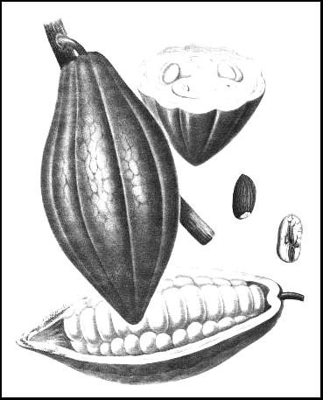
Fig. Theobroma cacao

MPM Description.—Seed with adherent inner layers of pericarp ellipsoidal or oblong-ovate, somewhat flattened, obtuse, 15 to 25 mm in length; externally reddish-brown to dark brown, with hilum at broader end, connected with chalaza at the narrower end by a raphe which runs along one of the narrower sides; the thin brittle shell separable from the embryo; embryo, oily, reddish-brown to chocolate-brown and consisting of 2 fleshy, peculiarly folded cotyledons and a short hypocotyl, the latter at the hilum end; odour agreeable, characteristic; taste oily, aromatic and bitter.
Cocoa powder is a weak reddish-brown to moderate brown powder, devoid of sweetness, and having a chocolate-like odour and taste. The diagnostic histological elements are: numerous small, simple, spherical or 2- to 3-compound starch grains up to 15 µm in diameter, some of which have become altered during the curing and roasting processes and appear swollen and resembling in size and outline the starch grains of wheat and corn; needle and prismatic shaped crystals of fat, numerous aleurone grains, numerous fragments of parenchyma of cotyledons with thin-walled cells, some containing brownish, reddish-brown, or purplish-brown cacao-red; fragments of epidermis of cotyledons with polygonal cells and reddish-brown granular contents.
According to the EP., Theobroma Oil (Cocoa Butter) is the solid fat obtained from the roasted seeds of Theobroma cacao L. Theobroma Oil is a yellowish white, solid fat; odour, slight, agreeable and resembling that of cocoa. Somewhat brittle. Freely soluble in chloroform, in ether and in petroleum spirit (boiling range, 40° to 60°); slightly soluble in ethanol (96%). Acid value: not more than 4.0. Iodine value: 35 to 40 (iodine monochloride method). Melting point: 31° to 34°. Refractive index: at 40°, 1.456 to 1.458. Saponification value: 188 to 196.
Constituents.—Cocoa seed: Fat (50%): chief fatty acids oleic acid (33 to 39%), stearic acid (30 to 37%), palmitic acid (24 to 31%). Purine alkaloids (3 to 4%): main alkaloid theobromine (2.8 to 3.5%), with a lesser amount of caffeine (0.1 to 0.4%). Proteic substances (10 to 16%). Starch (5 to 9%). Monosaccharides and oligosaccharides (2 to 4%): saccharose, glucose, fructose. Biogenic amines: phenyl ethyl amine, tyramine, tryptamine, serotonin. Isoquinoline alkaloids: salsolinol. Catechin tannins (10%): including oligomeric proanthocyanidins (8%). Oxalates (0.6 to 1%).
Cocoa seed coat: Fat (5%). Purine alkaloids: main alkaloid theobromine (0.4-1.2%) with less caffeine (0.02%). Biogenic amine: including phenyl ethyl amine, tyramine, tryptamine, serotonin. Proanthocyanidins.
Cocoa butter: Triglycerides (melting temperature 31 to 35°C): chief fatty acids oleic acid (33 to 39%), stearic acid (30 to 37%), palmitic acid (24 to 31%). Free fatty acids. Steroids: sterols, including β-sitosterol. Purine alkaloids (0.001 to 0.1%).
Pharmacological Action. Uses.—Cacao butter is used in the making of suppositories (suppository basis), as an excipient for certain pills, and as an emollient. Cocoa Butter is used by the pharmaceutical and cosmetic industries as an inactive ingredient in dermatologic preparations.
Cocoa seeds can cause constipation because of the tannin content. The drug contains methylxanthines, mainly theobromin, which have a diuretic, broncholytic, and vasodilatory effect. They also stimulate cardiac muscle performance and act as a muscle relaxant. Cocoa seed is also used as a mild stimulant (in compound drinks containing caffeine).
Cocoa is used medicinally to mask the taste of bitter substances like quinine. Its chief use is as a nutrient beverage.
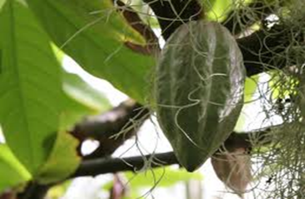Olea europaea

Botanical Origin.—Olea europaea L. (Engl. — Olive; Ukr. — Маслинаєвропейська; Rus. — Маслина eвропейская, олива). Family – Oleaceae.
Part Used.—Oleum Olivarum is the fixed oil obtained from the ripe fruits of Olea europaea L., Oleaceae.
Habitat.—Probably the Lebanon. The plant grows in almost all of the southern European countries and throughout the entire Mediterranean region as far as Iran and beyond the Caucasus. Olive trees are cultivated in many regions of the world.
Plant.—Olive grows as a medium high shrub or a tree up to 10 m high. The plant has pale bark and canelike, quadrangular to round, initially downy, thorny or thornless branches. The leaves are opposite, entire, stiff, coriaceous, evergreen, narrow elliptical to lanceolate or cordate with thorny tips. The upper surface is dark green, glabrous or covered with scattered scutiform hairs; the underside shimmers silver with scuitform hairs. The yellowish-white flowers are in small axillary clustered inflorescence (raceme). The calyx has 4 tips. The white corolla has a short tube and 4 lobes. The superior ovary is bilocular, with each side having 2 hanging anatropal ovules. The drupe has 1 to 2 seeds, is fleshy, plum-like or round. The smooth drupe is initially green, then red and finally blue-black when ripe. The very hard stone contains oblong compact seeds with many endosperm.
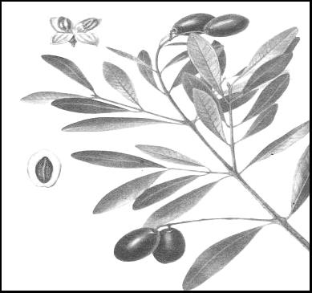
Fig. Olea europaea

MPM Description.—According to the EP., Virgin olive oil (Olivae oleum virginale)is the fatty oil obtained by cold expression or other suitable mechanical means from the ripe drupes of Olea europaea L.
Virgin olive oil is a clear, yellow or greenish-yellow, transparent liquid with a characteristic odour, practically insoluble in alcohol, miscible with light petroleum (50 °C to 70 °C). When cooled, it begins to become cloudy at 10 °C and becomes a butter-like mass at about 0 °C. It has a relative density of about 0.913. Acid value: not more than 2.0, determined on 5.0 g. Peroxide value: not more than 20.0. Unsaponifiable matter: not more than 1.5 per cent.
According to the EP., Refined olive oil (Olivae oleum raffinatum) is the fatty oil obtained by refining of crude olive oil, obtained by cold expression or other suitable mechanical means from the ripe drupes of Olea europaea L. A suitable antioxidant may be added.
Refined olive oil is a clear, colourless or greenish-yellow, transparent liquid, practically insoluble in ethanol (96 per cent), miscible with light petroleum (50 °C to 70 °C). When cooled, it begins to become cloudy at 10 °C and becomes a butter-like mass at about 0 °C. It has a relative density of about 0.913.
Acid value: maximum 0.3, determined on 10.0 g. Peroxide value: maximum 10.0; if intended for use in the manufacture of parenteral dosage forms: maximum 5.0. Unsaponifiable matter. Notmore than 1.5 per cent.
Constituents.—Olive oil: chief fatty acids are oleic acid (56-83%), palmitic acid (8- 20%), linoleic acid (4-20%). Steroids (0.125 to 0.25%): β-sitosterol, delta7-stigmasterol, delta5-avenasterol, campesterol, stigmasterol. Tocopherols (0.02%).
Pharmacological Action. Uses.—Olive oil is used in the preparation of parenteral drugs, soaps, plasters etc., and is widely employed as a salad oil. Through the presence of polyunsaturated fatty acids, Olive oil has an antisclerotic effect by positively influencing the serum lipids. Olive Oil Ear Drops are included into the EP. Its use as a lubricant for constipation and dry skin conditions appears plausible because of the oily characteristics. Internal uses of the oil in folk medicine include inflammation of the gallbladder, flatulence, constipation, gastrointestinal ulcers and kidney stones. Externally, it has been used for psoriasis, eczema, sunburn, mild burns and rheumatism.
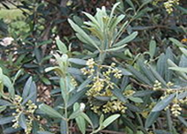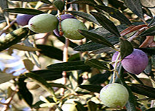

Helianthus annuus

Botanical Origin.—Helianthus annuus L. (Engl. — Sunflower; Ukr. — Соняшникоднорічний; Rus. — Подсолнечник обыкновенный). Family – Asteraceae.
Part Used.—Helianthi annui oleum raffinatum is the fatty oil obtained from the seeds of Helianthus annuus L. by mechanical expression or by extraction. It is then refined. A suitable antioxidant may be added.
Habitat.—Helianthus annuus is indigenous to central and eastern North America and is cultivated worldwide.
Plant.—The sunflower is a l to 3 m high annual plant with a long primary root and numerous lateral roots. The stem is erect, branchless or branched higher up, densely covered in hairs, and filled with thin white pith. The leaves are alternate, cordate-triangular, long-petioled, irregularly crenately serrate and covered with short bristles on both sides. The very large, composite flowers are solitary or in small clusters, usually nodding, and 10 to 40 cm wide on the stems. The bracts in a number of rows are leaf-like, ovate, acute and sparsely bristly. The 20 to 70 asexual, linguiform golden-yellow ray florets are 3 to 10 cm long and l to 3 cm wide. The numerous tubular disc florets are androgynous. They may be brown, purple or yellow, with black or purple anthers. There are small 3-pointed paleas on the base of the capitula. The fruit is compressed at the sides, obovate to almost wedge-shaped; it is an achaene. It is densely appressed, downy and whitish, straw yellow or gray to black.
MPM Description.—According to the EP, A clear, light yellow liquid, practically insoluble in water and in alcohol, miscible with light petroleum (bp: 40 °C to 60 °C). It has a relative density of about 0.921 and a refractive index of about 1.474.
Acid value: not more than 0.5, determined on 10.0 g. Peroxide value: not more than 10.0. Unsaponifiable matter: not more than 1.5 per cent, determined on 5.0 g.
Constituents.—Triglycerides: chief fatty acids are linoleic acid (35-62%), oleic acid (25-42%), palmitic acid (4-7%). Sterols campesterol, cholesterol, β-sitosterol.
Pharmacological Action. Uses.—Useful as a dietary supplement. Sunflower oil is used internally to alleviate constipation (as a lubricant). It is used externally as massage oil, for poorly healing wounds (as an oil dressing) and in the treatment of skin lesions, psoriasis and rheumatism.
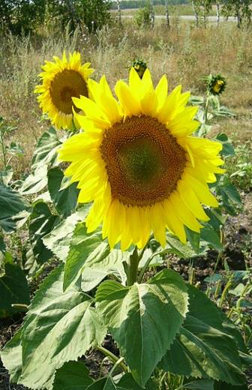
Apis mellifica

Zoological Origin.—Apis mellifica (Engl. — Worker bees; Ukr. — Бджола медоносна; Rus. — Пчела медоносная). Family – Apidae.
Part Used.—Cera (beeswax) is the purified honeycomb of Apis mellifica and other bees.
Production.—Yellow beeswax is prepared, after removal of the honey, by melting the comb under water (residual honey dissolving in the water and solid impurities sinking), straining, and allowing the wax to solidify in suitable moulds.
White beeswax is prepared from the above by treatment with charcoal, potassium permanganate etc., or by the slow bleaching action of light, air and moisture.
Description.—Beeswax is a yellowish – brown or yellowish – white solid. It breaks with a granular fracture and has a characteristic odour. It is insoluble in water and sparingly soluble in cold alcohol, but dissolves in chloroform and in warm fixed and volatile oils.
Yellow wax (Cera flava) is a yellow to brownish-yellow or grayish-brown solid occurring as variously molded cakes, brittle when cold and when broken exhibiting a dull granular, non-crystalline fracture; specific gravity 0.950 to 0.960 at 25°C; melting point between 62° and 65°C; odour honey-like; taste faint but characteristic.
Constituents.—Beewax is a true wax, consisting of about 80% of myricyl palmitate (myricin), with possibly a little myricyl stearate. It also contains about 15% of free cerotic acid, aromatic substance cerolein, hydrocarbons, cholesteryl esters.
Pharmacological Action. Uses.—Yellow wax is used in the preparation of ointments, polishes and plasters.
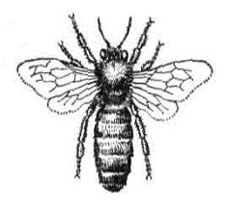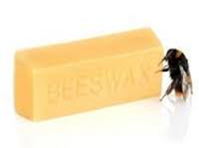
Ovis aries

Zoological Origin.—Ovis aries L. (Engl. — Sheep; Ukr. — Bівця свійська). Family – Bovidae.
Part Used.—Adeps lanae (Lanolinum) is a purified fat – like substance prepared from the wool of the sheep Ovis aries, Bovidae.
Production.—Raw lanolin is separated by ‘cracking’ with sulphuric acid from the washings of the scouring process and purified to fit it for medicinal use. Purification may be done by centrifuging with water and by bleaching.
Description.—A brownish-yellow, sticky, unctuous mass with only a slight odour; it mixes without separation with about twice its weight of water and melts between 36° and 42°C.
Like other waxes, it is not readily saponified by aqueous alkali, but an alcoholic solution of alkali causes saponification. Saponification value 90 – 105; iodine value 18-32; acid value not more than 1. Hydrous wool fat (Lanolinum hydricum) contains 25 % water (up to 30%).
Constituents.—Cholesterol and isocholesterol (monohydric alcohols) in combination with lanoceric, lanopalmitic and other fatty acids. Wool fat also contains aliphatic alcohols such as cetyl, ceryl and carnaubyl alcohols.
Pharmacological Action. Uses.—Wool fat is used as an emmolient base for creams and ointments.
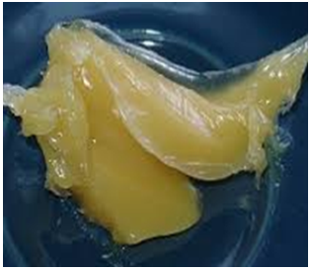
Physeter macrocephalus

Zoological Origin.—Physeter macrocephalus L. (Engl. — Sperm Whale, Cachalot; Ukr. — Кашалот; Rus. — Кашалот). Family – Physeterides.
Part Used.—Cetaceum is a waxy substance obtained from the head of the sperm whale Physeter macrocephalus, Physeterides.
Animal.—A huge, toothed whale averaging 20-30 m in length with a massive head, truncated in front and about one-third the length of the body. On the upper surface of its skull occurs a large cavity containing fatty tissue from which sperm oil and spermaceti are obtained. The flippers are short and antero-lateral. On the dorsal surface there occurs a rudimentary dorsal fin as a low projection.
Habitat.—Atlantic, Pacific and Indian Oceans.
Production.—The sperm whale is killed by torpedo harpoons which explode within its body. A short time after the animal is killed, the fat cavity is opened and the oil collected in buckets. This, upon hardening, forms a yellowish mass which is placed in bags, drained and pressed to remove olein, purified by melting in hot water and skimming, boiled with weak alkaline solution, washed with water and allowed to harden.
Its collection now is illegal.
Description.—Sperm Oil is a fixed oil obtained from the cranial cavity of the sperm whale, Physeter macrocephalus L.
Cetaceum (spermaceti) occurs in white, somewhat translucent, slightly unctuous masses, having a somewhat scaly-crystalline fracture, very faint odour and bland taste. It melts between 42° and 50°C. It is soluble in fixed and volatile oils, in boiling alcohol, and in chloroform and ether. On exposure to air it becomes yellow and rancid. The official drug must be free from rancidity.
Constituents.—Cetyl palmitate or cetin (C₁₅H₃₁COOC₁₆H₃₃) and small percentages of other fatty substances.
Pharmacological Action. Uses.—As a base for cerates and ointments. Sperm oil is widely used as a lubricant for machinery, especially sewing machines.
